Staff Presence Detection using YOLO11s and ResNet18
1. Summary
A YOLO11s + ResNet18 architecture is designed: YOLO11s for person-in-frame detection and ResNet18 for name tag wearing identification.
As no dataset was provided, to avoid manually drawing bounding boxes, ResNet18 is selected and trained with Gemini-generated name tag wearing images.
The trained ResNet18 classifier achieved 100% accuracy, precision, and Recall on the validation set. However, the architecture’s performance on the sample video is disappointing. A lot of staff in the frame are misrecognized by YOLO11s, and the accuracy of ResNet18 is below expectations.

2. Methodology
The proposed pipeline consists of two stages:
Stage 1 – Person Detection
YOLO11s was selected for person detection because it provides a good balance between detection accuracy and inference speed. ByteTrack was used to assign a persistent tracking ID to each detected person across consecutive frames.
To reduce unnecessary computation, each tracked person is classified only once every fixed number of frames. Intermediate classification results are cached and reused while the person remains visible.
This significantly reduces the number of CNN inferences while maintaining consistent predictions.
Stage 2 – Name Tag Classification
Instead of training an object detector for name tags, a ResNet18 image classifier was adopted.
This decision was made because no annotated name tag bounding boxes were available. A classification model only requires image-level labels (with or without a name tag), eliminating the need for manually drawing bounding boxes around each name tag.
Each person detected by YOLO is cropped and resized before being passed to the classifier.

3. Dataset Preparation
Since no training dataset was provided, a custom dataset was created.
Positive Samples
98 positive images were generated using Gemini 2.5 Flash Image (via API).
Reference images together with carefully designed prompts were supplied to Gemini to generate realistic staff wearing the target name tag under different poses and appearances.
Negative Samples
150 negative images were collected from the Market-1501 person re-identification dataset.
The selected images contain people with different clothing colours, body poses and viewing angles, but without wearing the target name tag.
Initially, additional negative samples containing people wearing different styles of name tags were generated. The intention was to train the classifier to recognise only the target company name tag.
However, experiments showed that the classifier predicted almost every person as "No Name Tag". This is likely because the surveillance video resolution is low and the name tag occupies only a very small region of the cropped person image, making it difficult for ResNet18 to distinguish different name tag designs.
Therefore, the final model focuses on detecting whether the target name tag is present rather than distinguishing between different types of name tags.

4. Data Augmentation
To improve robustness against surveillance video conditions, several augmentation techniques were applied during training: Random proportional down-scaling, Gaussian Blur, Random Horizontal Flip, Random Rotation, Random Perspective Transformation, and Random Affine Transformation
The down-scaling augmentation was specifically designed after analysing the cropped person sizes extracted from the sample video. Most detected persons were relatively small (approximately 90 × 110 pixels), therefore, simulating low-resolution images during training helped reduce the domain gap between synthetic images and surveillance footage.

5. Training Result
The dataset was split using an 80/20 train-validation ratio.
The ResNet18 classifier achieved 100% of Accuracy, Precision and Recall on validation set. These results indicate that the classifier learned the synthetic dataset successfully.

6. Testing on Sample Video
Although the standalone classifier achieved excellent validation performance, the complete video pipeline performed noticeably worse on the provided sample video.
Two major issues were observed.
6.1 Person Detection Failure
Some people were not detected by YOLO11s.
Possible reasons include:
- The surveillance camera is mounted at a relatively high angle.
- The COCO dataset used to pre-train YOLO mainly contains front-view or side-view pedestrians.
- The sample video resolution is only 960 × 720, while the scene contains many people and background objects, making person detection more difficult.
Since undetected people are never cropped, they cannot be classified by the downstream classifier.

6.2 Name Tag Classification Errors
The classifier occasionally misclassified whether a person was wearing a name tag.
Possible reasons include:
- The surveillance viewpoint differs significantly from the Gemini-generated training images.
- The cropped person images are relatively small.
- The name tag occupies only a tiny portion of the person image, making it difficult for the classifier to extract discriminative features.
This represents a classic domain shift problem: the training data distribution differs substantially from the deployment environment.

7. Future Improvements
For real-world deployment, synthetic data should be replaced or supplemented with data collected directly from the target surveillance cameras.
The recommended workflow is:
- Collect real surveillance footage.
- Annotate person bounding boxes.
- Annotate whether each person is wearing the target name tag.
- Fine-tune both the YOLO detector and the ResNet classifier using these real samples.
Training with deployment-specific data would significantly reduce the domain gap and improve both detection and classification performance.

8. Conclusion
A two-stage computer vision pipeline combining YOLO11s, ByteTrack, and ResNet18 was proposed for staff presence detection.
Despite the lack of a provided training dataset, a complete synthetic training dataset was created using Gemini-generated images and publicly available pedestrian datasets. The classifier achieved perfect validation performance on the constructed dataset.
Although performance on the provided surveillance video remains limited due to viewpoint differences and low image resolution, the overall pipeline demonstrates a practical and extensible solution that can be further improved through fine-tuning on real deployment data.
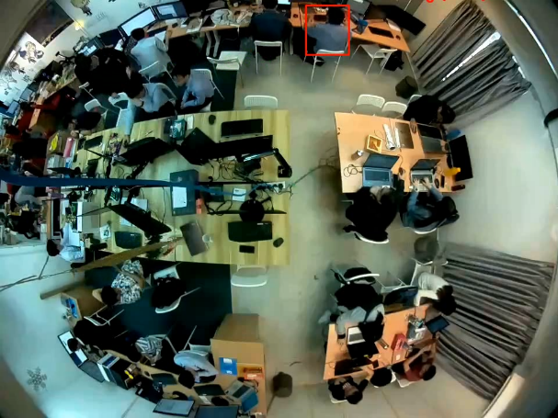  Figure 1 Most staff in frame are missed | 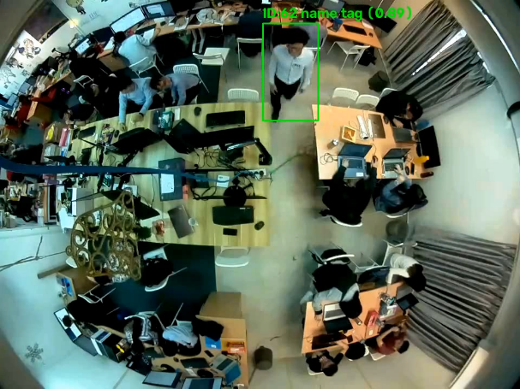  Figure 2 The staff with name tag are correctly detected
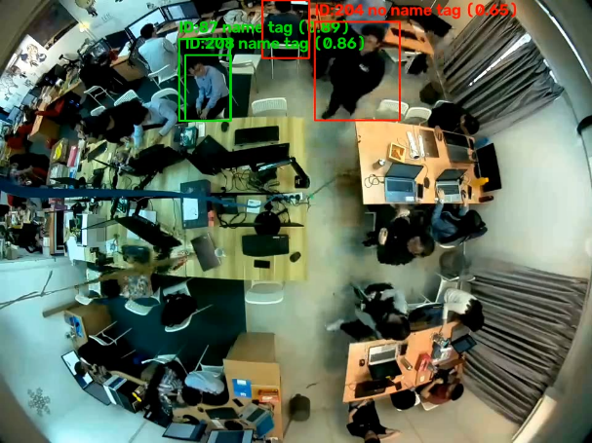  Figure 3 Totally wrongly detected | 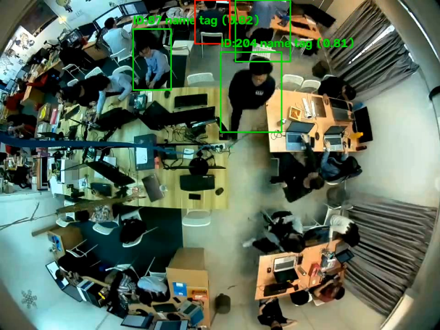  Figure 4 Mix of correct and wrong detection

